Team SQL-Poornima University

Project (Ratio of cost of job)

11-May-2020(Monday)

All the members are working over concepts learn previously. The tasks to be covered by EOD are:

* Task 1

with ratio

as(

select sum(case when country='INDIA' then salary else 0 end) as India,

sum(case when country<>'INDIA' then salary else 0 end) as International,

sum(salary) as salary from employees)

select (India*100)/salary as India, (International*100)/salary as International from ratio;

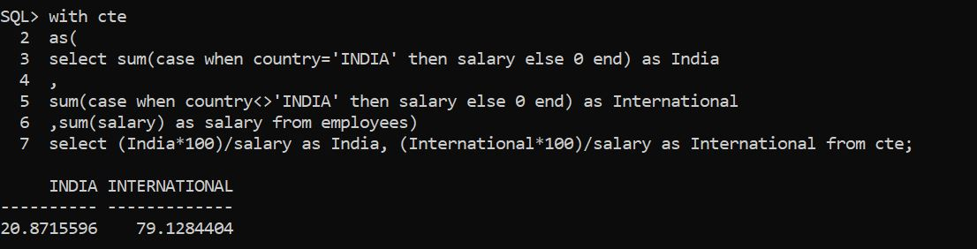/*this will fetch the data according to the description*/

* Task 2
  + with cte

2 as(

3 select sum(cost)/sum(revenue_collection) as ratio, to_char(dob,'yyyy-mm') as Dob from project_detail

4 group by to_char(dob,'yyyy-mm')

5 order by 2)

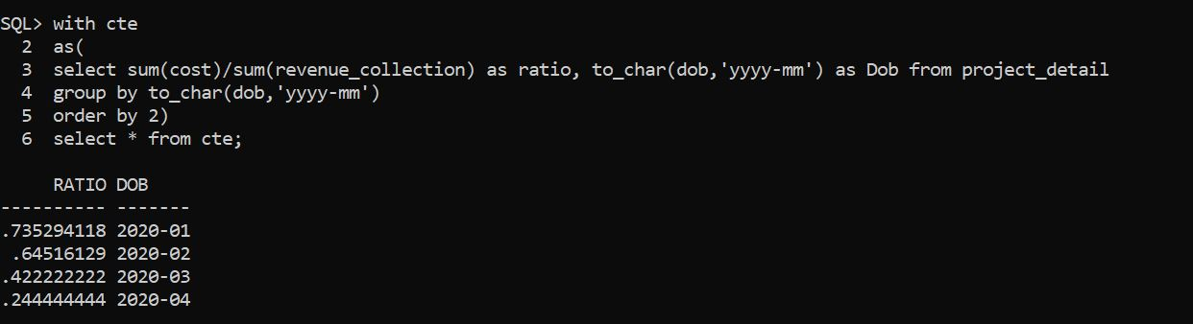6 select * from cte;

Each team member would be updating the progress in the drive by EOD.

Thank you